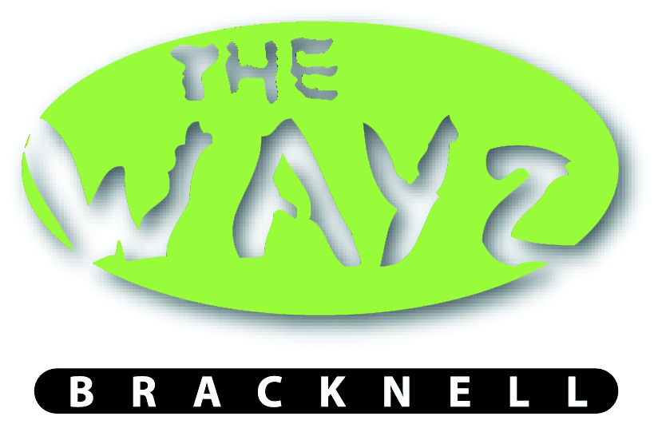
Calfridus Way
Bracknell
Berkshire
RG12 9ET
(01344) 483596

LETTINGS / PRIVATE HIRE

Conditions

- The hirer agrees that all requirements relevant to the letting will be complied with (including any necessary licence required for the use of the premises) and that all personnel employed by the will be advised of these requirements and of these conditions.

- All hirer must go through an induction of all equipment available when setting up, operating and packing down, along with any procedures that are associated with the hire.

- The hirer must adhere to the agreed hire times made by the Youth Worker and Hirer stated on the contract to prevent any extra charge or suspension of the contract.

- The hirer accepts full responsibility for any damages to or theft of the club’s property occurring during the period for which the premises are hired.

- The club accepts no responsibility for the loss of any property brought into or left in the premises during the letting

- The hirer agrees that no equipment will be used without the approval of the Youth Worker of the Club and that the installation of the hirer’s equipment will be carried out by competent personnel.

- The hirer further agrees to indemnify The Wayz against all claims, actions, liabilities arising from the use of the premises by the hirer apart from claims and actions arising through the negligence of its servants or agents.

- The hirer must ensure that a responsible person will be present at all times during the period of the letting.

- Any cleaning undertaken which in the opinion of the Youth Worker occurs as a result of the hiring will be charged to the hirer at the appropriate rate. (at the same as the agreed hourly booking rate)

- The hirer accepts that he/she should familiarise himself/herself with the position of telephones, escape routes, fire alarms and fire fighting equipment. Notices regarding the procedures in relation to action in the event of a fire should also be studied.

- A minimum cancellation time of 14 days is required, if this is not met that the hirer will still be charged.

- The hirer agrees that no alcohol will be brought into the hall or grounds for consumption.

- For users safety we have operational CCTV cameras inside and outside the building. Recordings from the cameras will be kept for 30 days and then deleted.

Insurance Arrangements

There is cover under the Club’s Public Liability Insurance insofar as injuries arising from a defect of The Wayz premises or of the contents of the building are concerned. There is, however, no cover against any injury arising from some action or negligence by the hirers. Hirers should therefore note that they must accept responsibility for suitable supervision and for taking out adequate insurance cover.

I accept the conditions set out above in relation to the hiring of The Wayz and fully understand the position concerning insurance.

Signed: ……………………………………………………

Dated: ……………………………………………………

APPLICATION FORM FOR HIRE OF PREMISES
Name & Address of Hirer: …………………………………………………………..

…………………………………………………………..

…………………………………………………………..

Telephone Number: ……………………………………

Description of Letting: …………………………………………………………..

Date Premises Required: …………………………………………………………..

Actual Time of Function From:…………….. To:…………….

Total Time Premises Required
(including setting up and clearing away) From:…………… To:……………

Does the Hirer require keys (only on numerous dates required) YES …... NO ……

PLEASE NOTE CENTRE KEYS SHOULD ONLY BE HELD BY INDIVIDUAL SIGNED BELOW AND SHOULD NOT BE COPIED EXTERNAL OF CENTRE MANAGER, IF THIS IS SEEN AS NOT THE CASE THEN THE CENTRE HAS THE RIGHT TO TERMINATE THE BOOKING.
Equipment Required

The Hiring of the building entitles the hirer to gain access of the following rooms and equipment
Kitchen |  | Microwave |  |  | Main Hall
 |  | Kettle |  |  | Screen |  | Table tennis
 |  | Fridge/Freezer |  |  | Projector |  | Bluetooth speaker
 |  | Sink and washing up |  |  |  |  | Table Football
Pool Room |  | Table |  |  | Sports Hall |  | Bouncy Castle
 |  | Cues |  |  |  |  | Soft Play
 |  |  |  |  | Informal Learning Zone |  | Interactive whiteboard
 |  |  |  |  |  |  | Television
Furniture |  |  |  |  |  |  | Flip Chart
 |  | Tables
 |  | Chairs

The charge for the Hire of The Wayz will be £… …. Per Hour

TOTAL HIRE CHARGE £…………….

- Booking will not be confirmed until a 25% deposit has been made.
- Payment in full required at least 14 days prior to booking date
- Payment via BACS, bank account details are as follows:
CAF Bank
Account name: The Wayz
Sort code: 40-52-40
Account no.: 00030267

The Hirer will be responsible for the cost of repair of any damage done to the premises or its contents during the period of hire.

Signed: ………………………………………. Date: …………………………………..
(Signature of Hirer)

